**A Project on Customer satisfaction** with the quality of products that are supplied & manufactured by BHEL: A case study on export of Gas Turbines to Oman

**CHAPTER 1**

**Introduction and Background to the Study**

**CHAPTER I**

**1.1 INTRODUCTION**

Today’s financial challenges accentuate the need for quality and change. Improvements to processes have saved hundreds of thousands of dollars across Finance & Facilities. Understanding the principles and methods, and how you can streamline and sustain process improvement on a continuous basis, can contain and lower costs, while increasing customer-defined value.

The state-of-the-art in system development management has evolved over the last few decades from basic concepts, practices, techniques, and tools borrowed from other disciplines to a relatively sophisticated suite of training, guided experience, and performance evaluation using structured collections of proven best practices. Experience has shown repeatedly that careful planning, frequent, regular review by trained, qualified people, and meticulous control of product components as they are developed, while not automatically sufficient by themselves, are necessary to defining and fielding a complex product or system today. The technology product and service industry as a whole has attempted numerous times to define, document, and disseminate collections of sound practice and specifications of product quality. These have taken the form of standards, specifications, methods, tools, books, and training and certification programs, among others.

**1.2 TOTAL QUALITY MANAGEMENT**

Total Quality Management (TQM) is a combination of quality and management tools aimed at increasing business and reducing losses due to wasteful practices. An important part of **TQM** is its philosophy toward continually improving your business and products.

The **basic principles** for the Total Quality Management (TQM) philosophy of doing business are to satisfy the customer, satisfy the supplier, and continuously improve the business processes.

This would basically aim at three things –

* How do you satisfy the customer?
* Why should you satisfy the supplier?
* What is continuous improvement?

**1.3 Satisfy the Customer**

The first and major TQM principle is to satisfy the customer, the person who pays for the product or service. Customers want to get their money's worth from a product or service they purchase.

If the user of the product is different than the purchaser, then both the user and customer must be satisfied, although the person who pays gets priority.

A company that seeks to satisfy the customer by providing them value for what they buy and the quality they expect will get more repeat business, referral business, and reduced complaints and service expenses.

BHEL not only provide quality products, but they also give extra service to make their customers feel important and valued.

Often in a company, there is a chain of customers, -each improving a product and passing it along until it is finally sold to the external customer. Each worker must not only seek to satisfy the immediate internal customer, but he or she must look up the chain to try to satisfy the ultimate customer.

**1.4 Satisfy the Supplier**

A second TQM principle is to satisfy the supplier, which is the person or organization from whom you are purchasing goods or services.

External suppliers: A company must look to satisfy their external suppliers by providing them with clear instructions and requirements and then paying them fairly and on time. It is only in the company's best interest that its suppliers provide it with quality goods or services, if the company hopes to provide quality goods or services to its external customers.

The third principle of TQM is continuous work.

# Continuous improvement: You can never be satisfied with the method used, because there always can be improvements. Certainly, the competition is improving, so it is very necessary to strive to keep ahead of the game.

# 1.5 TQM Requirements

## The common elements of a successful shift to TQM are:

* Top Management commitment / leadership.
* Shared Values - Policy Deployment.
* Line Management ownership.
* Cascade training in TQM – compulsory.
* Widespread use of teams / councils / committees.
* Employee involvement / empowerment.
* Recognition and celebration.
* Voice of the customer.
* Challenging quantified goals - benchmarking.
* Focus on processes / improvement plans.
* Specific incorporation in strategic planning.
* Supported in all Management appraisal.

**TQM PRINCIPLES**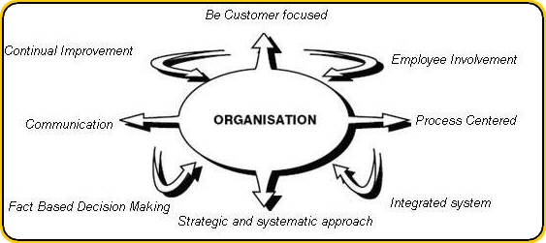

The 5 Key principles of TQM are:

* + - Management Commitment
    - Employee Empowerment
    - Fact Based Decision Making
    - Continuous Improvement
    - Customer Focus

**1.6 NEED & IMPORTANCE OF STUDY**

The main objective of this research is to examine whether the customer located at OMAN are satisfied with the product quality supplied by BHEL, Hyderabad.

Since BHEL is a public sector unit, there might be major chances that the company might not follow total quality management (TQM). As the main aim of the TQM is to improve overall processes in the organization by reducing losses, and increasing customer satisfaction, there is a need to study whether TQM is been implemented or not.

Quality is major concern in many of the organizations. Implementing TQM would bring down many of the problems in the organization. Continual improvement in the management system would increase the productivity of the organization. It would in turn increase the stake value of the holder. This study has not been conducted before and hence there is an urgency to conduct this kind of the research.

This concept was suggested in order to reduce the defects in the stator laminations and increase the productivity of the stator laminations. It also helps management to know the opinion of the customers located at OMAN to understand the satisfaction levels of the product quality supplied by BHEL.

Hence this study is to improve the processes in the organization by customer feedback, and by reducing the manufacturing defects by enhancing the quality.

**1.7 REVIEW OF LITERATURE**

TQM is a culture advocating a total commitment to customer satisfaction, through continuous improvement and innovation in all aspects of the business. The customer, in the TQM culture, does not mean only the final recipient of the organization's end product or services. The customer is also every individual or department within the organization (Logothetis, 1992).

The TQM culture varies from one company to another and from one industry to another. However, the TQM culture, regardless of its differences from one company to another, aims to achieve common objectives; namely removal of waste, reduction of costs, improvement of reputation and increased market share. As can be observed, TQM objectives are dynamic in their nature and this dictates continuous updating and upgrading (Logothetis, 1992).

The early development of Total Quality Management was influenced by a few Quality ‘Gurus’: Deming, Juran, Feigenbaum, Crosby and Ishikawa. Their key contributions to the quality movement will now be looked at.

The work of Deming The main thesis of Deming is that by improving quality, it is possible to increase productivity which results in improved competitiveness of a business enterprise. According to Deming, low quality results in high cost which will lead to loss of competitive position in the market. His approach can be summarized in his 14 point programme (Gaither& Frazier 1999, p. 634)

The work of Juran Unlike Deming whose approach was more process oriented, the ideas of Juran were having a managerial flavor (Kruger 2001). His main contribution was that quality control must be an integral part of the management function. This broadened the understanding of quality. Visible leadership and personal involvement of top management is important in inspiring quality across the organization.

According to Juran (1988), to demonstrate commitment to quality the management establish a quality council which would coordinate the company’s various activities regarding quality. Further, the management should establish a ‘quality policy’ which should guide the managerial action. The management has to establish quality goals which should be expressed in numbers and should have a time frame. Once a specific goal has been established by the management, it is the responsibility of the management to provide the necessary resources to achieve the quality goals.

Juran developed the improvement spiral showing that quality improvement is a continuous process and not just a programme with start and end point (Bauer, Reiner & Schamschule 2000). Later these very concepts were incorporated in the ISO 9000: 2000 standard.

Ishikawa: He recognized that for TQM to be successful, the tools and techniques of using data to make decisions must be understood by the workers and first-line supervisors /managers. Accordingly, his techniques and the explanation for application are simple and straightforward. For him, the ultimate purpose of data is to take action based on data. Thus data can be used for understanding the actual situation, analysis, process control and regulation as well as for the traditional acceptance and rejection decisions. (Ishikawa 1985:44)

Crosby: While Deming and Juran described the TQM philosophy and Ishikawa provided the tools and techniques, Crosby offered a detailed guide to implementation. He proposed a quality management grid that described the stages of TQM implementation relative to management’s understanding and problem-solving techniques, the organizational approach, and the results achieved. Each stage of Crosby’s matrix represents an increasingly mature implementation of the TQM philosophy (Crosby 1981).

Feigenbaum: He can be considered the originator of the concept of total quality control. Quality is the responsibility of everyone in an organization. Quality is produced not only by the production department, but also by marketing, finance, purchasing, and any other department. (Feigenbaum 1983:7)

**CHAPTER 2**

**Bharat Heavy Electricals Limited (BHEL):**

**The Profile**

**CHAPTER** **II**

**2.1 Bharat Heavy Electricals Limited PROFILE `**

Bharat Heavy Electricals Limited (BHEL) is one of the largest engineering enterprises of India. BHEL was established more than 45 years ago when its first plant was set up in Bhopal, India. BHEL is listed public company with turnover more than US$ 10 Billion Dollars paying dividends consistently since 1976.

BHEL is among the few power plant equipment manufacturers in the world that can supply almost entire range of critical systems out of their own manufacturing bases. BHEL caters to the core sectors of economy viz., Power Generation & Transmission, Industry, Transportation, Renewable Energy, Defense, etc. BHEL offers 180 products in 30 product groups and specialized long term services to the customer, thereby providing a single windows interface to the clients.

BHEL’s 17 manufacturing plants with modern engineering/ manufacturing/ testing facilities, 9 service centers, 4 regional hubs, over 50 diversely located offices, and currently operate at more than 150 project sites across India and abroad project site at any point of time, focus their resources to customer needs. All facets of its manufacturing and service operations are accredited to ISO 9000 series of quality systems. Most of manufacturing units and other entities have been accredited to

Quality Management Systems (ISO 9001:2008),

Environmental Management Systems (ISO 14001:2004) and

Occupational Health & Safety Management Systems (OHSAS 18001:2007).

BHEL has also acquired technology & capability to manufacture 660/800 MW supercritical boilers along with matching Steam Turbines & Generators, which are being manufactured presently. BHEL serves a large gamut of industries like power transmission, mining, metallurgy, cement, oil exploration, petro-chemical & refining, sugar, pulp & paper, transportation, etc. supplying critical equipment like special boilers, heat exchangers, industrial turbines, compressors, industrial & oil field valves, substation, transformers, motors, control systems, etc. BHEL also specializes in supply of eco-friendly solar thermal systems, solar photo-voltaic systems and wind electric generators. These products including expert services have been supplied to over 70 countries today.

BHEL’s technological allies range from GE-USA, Siemens-Germany, Henry Vogt-USA, May & Christie-France, ABB-Sweden, GEC-Alstom-France, Toa-Japan, Hitachi-Japan, Dresser-USA, Kaverner National Oil well-USA, etc. Through its diversified experience in terms of products, services, technology and supply to projects in most demanding logistics, terrain and climatic conditions, BHEL continues to grow as a reliable partner sharing its strength

BHEL company has been honored with several awards which included

• EEPC Star Performer Award in the Product Group of Project Exports for 20th consecutive year

• SCOPE Award for Sector Management.

• Dainik Bhaskar India Pride Award: 2010 in Heavy Industries Category.

• ICWAI National Awards for Excellence in Cost Management for 2009 among public and private sector companies for the fifth successive year.

• India Power Award for Equipment Manufacturing and for electrifying Lakshadweep Island Excellence and Outstanding Contribution to the Public.

• Six Prime Minister's Shram Awards including one "Shram Bhushan" and Three Vishwakarma Rashtriya Puraskars

• IEI Industry Excellence Award 2010 for Overall Business Excellence and Industry Practices from the Institution of Engineers (India).

NDTV Profit Business Leadership Award 2010

**2.1.1 VISION, MISSION AND VALUES:**

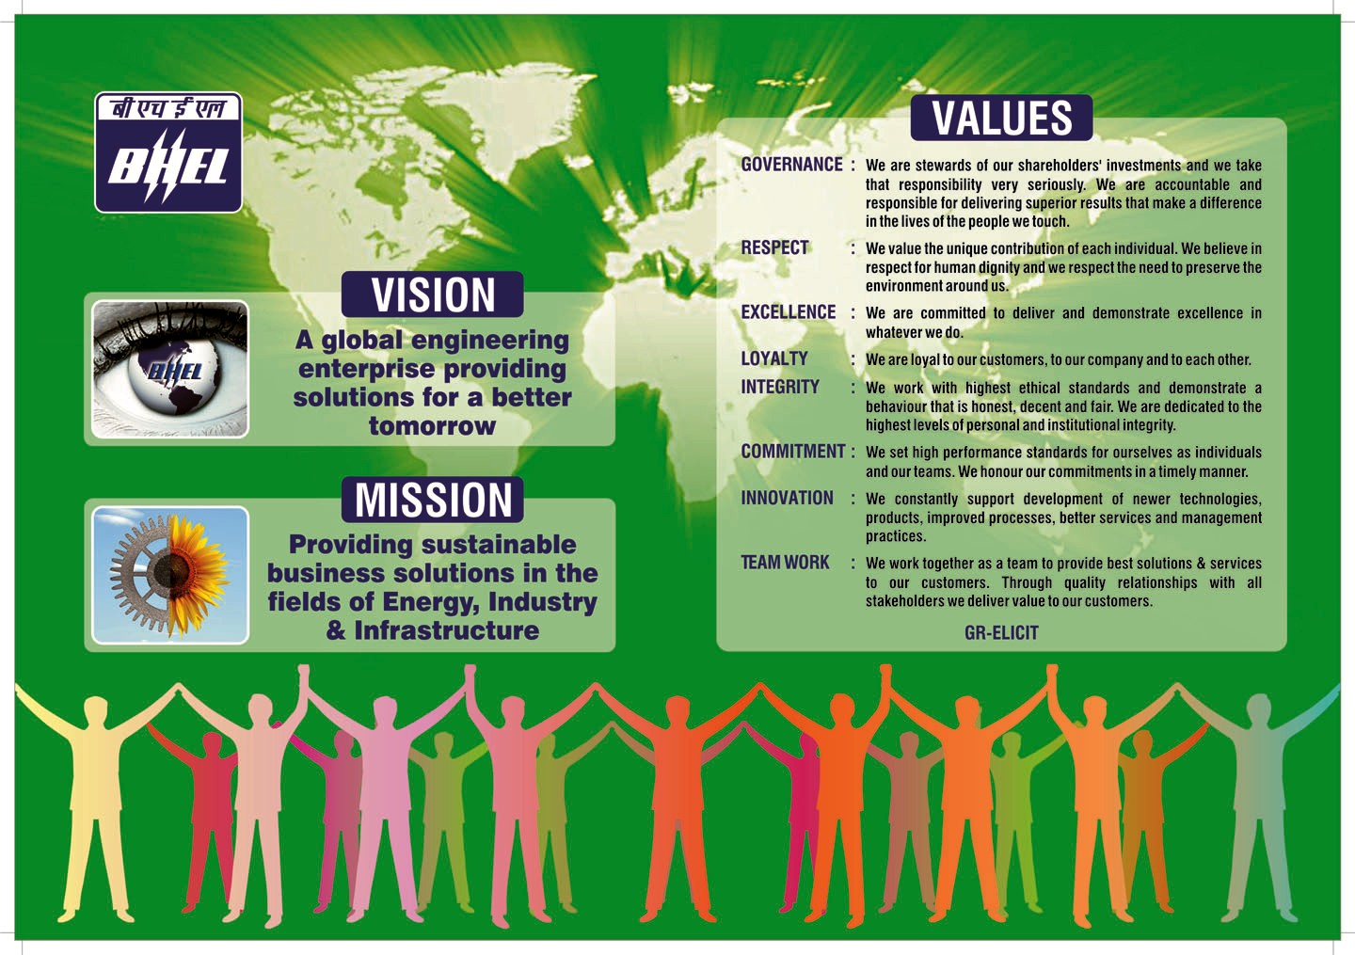

**2.1.2 Major products of BHEL unit’s manufacture include the following**

1. Gas turbines
2. Steam turbines
3. Compressors
4. Turbo generators
5. Heat exchangers
6. Pumps
7. Pulverizes
8. Switch gears
9. Gear boxes
10. Oil rigs

**2.2 INTERNATIONAL BUSINESS**

In international arena, the prevailing environment of heightened uncertainties worsened by political turmoil in the Arab world has adversely affected the business prospects of BHEL's traditional markets. In spite of such situation; BHEL was able to sustain its exports momentum and expanded its foot print in new markets.

The company is poised to maintain its references in the overseas market encompassing almost the entire range of products and services, covering thermal, hydro and gas-based turnkey power projects, substation projects, and rehabilitation projects, besides a wide variety of products like transformers, motors, compressors, valves, electrostatic precipitators, photovoltaic equipments, insulators, heat exchangers, and switchgears etc.

The company has been successful in meeting the requirements of international markets in terms of complexity of work as well as technology, quality and other requirements.

BHEL has proved its capability to undertake projects on fast-track basis. Continued focus on after-sales-services led to orders for spares & services from UAE, BANGLADESH, Nepal, France, Srilanka, Kazakhstan, IRAQ, Newzealand, Malta, Thailand, Yemen and Libya.

Besides undertaking turnkey projects on its own, BHEL also possesses the requisite flexibility to interface and complement other international companies for large projects, and has also exhibited adaptability by manufacturing and supplying intermediate products.

**2.3 BHEL in global presence**

**2.4 Tabular Representation of Major Competitors**

|  |  |  |
| --- | --- | --- |
| **S.NO** | **COMPANY** | **COUNTRY** |
| 1 | Ansaldo | Italy |
| 2 | Asea Brown Boueri | Switzerland |
| 3 | Beetel | USA |
| 4 | Block & Neatch | USA |
| 5 | CNMI & EC | China |
| 6 | Costain | U.K. |
| 7 | Electrim | Poland |
| 8 | Energostio | Russia |
| 9 | Electro Consult | Italy |
| 10 | Franco Tosi | France |
| 11 | Fuji | Japan |
| 12 | GEC Alsthom | U.K. |
| 13 | General Electric | USA |
| 14 | Hitachi | Japan |
| 15 | Mitsubishi | Japan |
| 16 | Mitsui | Japan |
| 17 | Raytheon | USA |
| 18 | Rolls Royce | Germany |
| 19 | Sanghai Electric Co. | China |
| 20 | Seimens | Germany |

**2.5 International Customers**

1. M/s ebara corporation, Japan
2. M/s zeeco incorporation, USA
3. Simmco international
4. Siemens, Germany
5. Siemens, Singapore
6. Baiji project, Iraq
7. Kycr coil industries ltd, Bangladesh

**2.6 Import**

An import is any good or service brought into one country from another country in a legitimate fashion, typically for use in trade.

Import goods or services are provided to domestic consumers by foreign producers.

Import of goods normally requires involvement of the Customs authorities in both the country of import and the country of export and is often subject to import quotas, tariffs and trade agreements.

**2.7 Export**

Exports are one of the oldest forms of economic transfer, and occur on a large scale between nations that have fewer restrictions on trade, such as tariffs or subsidies.

Most of the largest companies operating in advanced economies will derive a substantial portion of their annual revenues from exports to other countries

**2.8 Procedure for exports and imports adopted by BHEL**

**Licensing:-**Initially the licensing department after forming a contract applies for licensing

To obtain licensing, following documents are required**:**

* Copy of contract
* Copy of epcg license obtained by customer
* Payment terms
* Duration
* List of goods
* CA certificate for export performance for past 3 years, etc.

Submission of these documents to top management ensures further proceedings.

Only after providing with licensing the further activities proceeds it is the prior step in the foreign exchange department.

With licensing prior to commencement of import and export activities provides with eliminating customs and other taxes by government this facilitates foreign exchange.

**2.9 Flow Chart of Export Procedure**

**2.10 PROFILE OF BHEL GAS TURBINES**

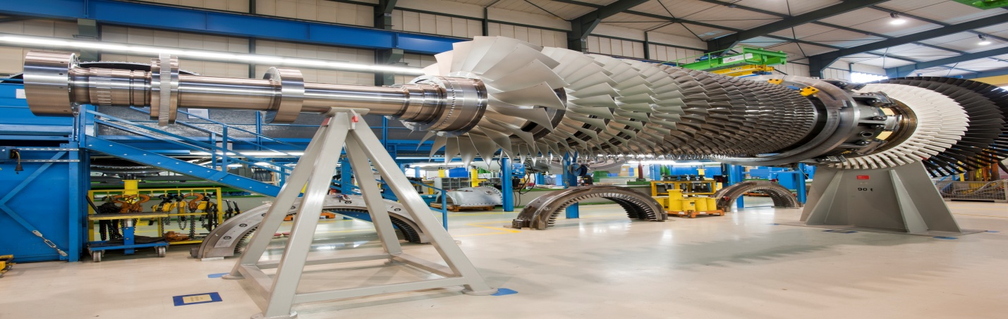

BHEL manufactures a complete line of Heavy Duty Industrial Gas turbines for all utility and Industry applications. They are installed in Refineries, Petrochemical plants, Gas compression stations, and Power generation plants in India and abroad.

BHEL has long-standing experience in manufacturing Gas turbines dating back to 1986 when a Collaboration agreement was established with GE (U.S.A.) to complement the existing portfolio of products.

A proven combination of sound design and quality assurance techniques places these gas turbines among the world's most reliable machines. Basic models produced by BHEL cover the 25,000 to 290,000 kW power range.

Extensive research and development, advanced design procedures, modern manufacturing technology and on-site experience are behind the success achieved by BHEL gas turbines. BHEL has already installed over 190 gas turbines with cumulative fired hours of over 13 million.

Apart from India, BHEL machines are working in Bangladesh, China, Iraq, Malaysia, Oman, Saudi Arabia, Srilanka and Kazakhstan.

**2.11 BHEL’s ACTIVITIES IN OMAN**

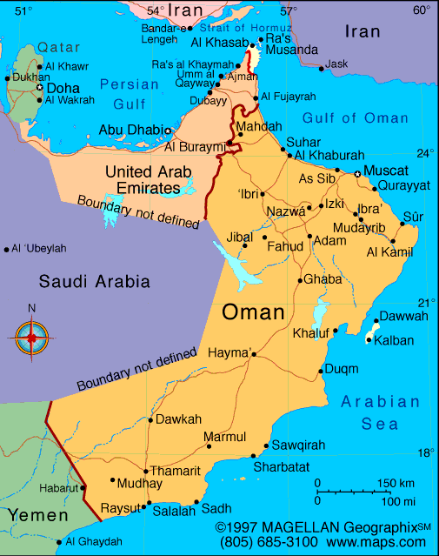

The Sultanate of Oman is in the Middle East, on the eastern end of the Arabian Peninsula. It is bordered by the United Arab Emirates, Saudi Arabia, and Yemen.  
Oman is the major target export market of BHEL where it made an entry in 1995 by securing the first order for a power project. This was followed by a series of orders and during the last 17 years.

BHEL has secured 14 major contracts which include seven Power Projects on EPC basis from diverse Sectors viz.

1. Petroleum Sector (Petroleum Development Oman);

2. Utility (Ministry of Housing, Electricity & water Oman);

3. Industry (Oman Cement Company),

which is a testimony of BHEL strong presence and acceptability in Oman market.

BHEL supplied sets today account for over 50 per cent of the power generating capacity of Petroleum Development Oman .BHEL’s global references spread across 76 countries and include the entire gamut of BHEL’s products and systems such as Power plants (Thermal, Gas and Hydro), Turbines, Generators, Sub-stations, Transformers, Motors, Photo Voltaic modules, Oil Field equipment and Transportation equipment, etc.

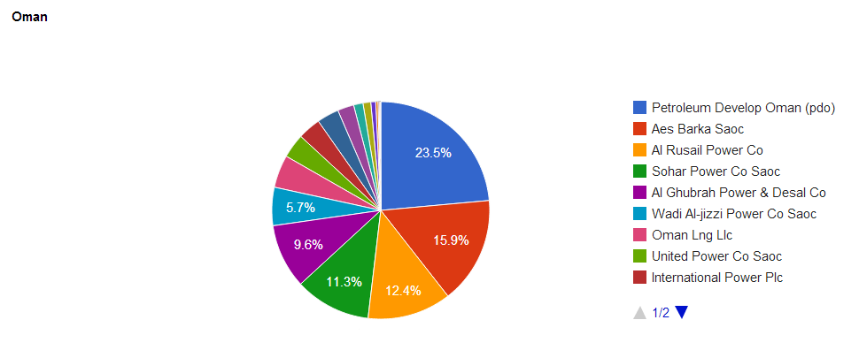

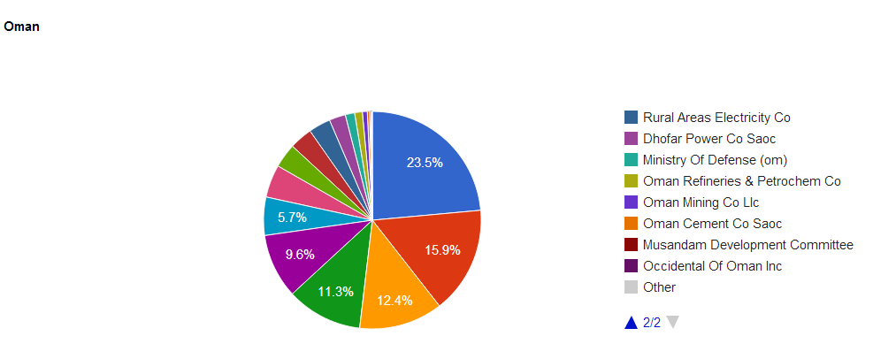

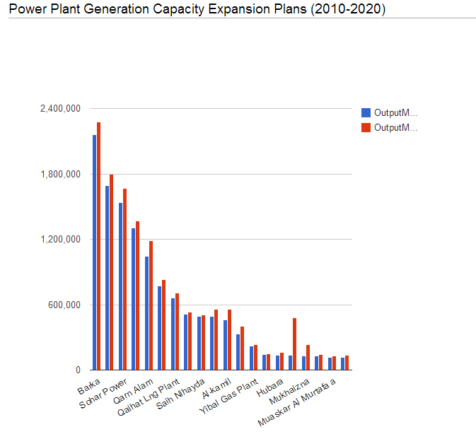

* 1. **CONCLUSION**

Having provided an overview of the company profile in this chapter with introduction about the export and import procedure followed by the company and also about the product description and finally about the activities that the company is doing in the Oman. The major objectives of the research project along with the hypothesis will be discussed in the coming chapter.

**CHAPTER 3**

**RESEARCH METHODOLOGY**

**CHAPTER** **III**

**RESEARCH METHODOLOGY**

**3.1 INTRODUCTION**

In this chapter, the empirical study is intended to address the research problem (formulated in Chapter One).

Research is regarded as a process of enquiry and investigation. It is a methodological, orderly process where correct methods are used to collect and analyze data. Research is regarded as an instrument that escalates knowledge.

**3.2THE RESEARCH PROCESS**

* The formulation and clarification of the research topic
* The literature review
* The adoption of the research strategy
* Data collection
* Data analysis

**3.3 OBJECTIVES OF THE STUDY**

The objectives of the study are as follows:

* To evaluate the customer feedback on the product supplied by BHEL
* To help workers reduce the defects & improve the quality of Gas Turbines.
* To suggest/recommend required improvements needed to be made to enhance much better customer satisfaction on the product.

**3.4 RESEARCH HYPOTHESIS**

**H01:** there is no significance difference between customer focus & the designation in the company.

**H02:** there is no significance difference between commitment levels & the designation in the company.

**H03:** there is no significance difference between Quality Losses & the designation in the company.

**H04:** there is no significance difference between Timely Delivery & the designation in the company.

**H05:** there is no significance difference between Continuous Improvement & the designation in the company.

**H06:** there is no significance difference between Problem Identification & the designation in the company.

**H07:** there is no significance difference between Service Levels & the designation in the company.

**H08:** there is no significance difference between Team Work & the designation in the company.

**H09:** there is no significance difference between Training & the designation in the company.

**H010**: there is no significance difference between Management Support & the designation in the company.

**H011**: there is no significance difference between TQM Implementation & the designation in the company.

**Ho12** = they are satisfied with the quality of products supplied by BHEL.

**3.5 DATA SOURCES**

Towards the accomplishment of above said objectives, information would be obtained from primary as well as secondary data sources

* **Primary Source**:

Questionnaire

* **Secondary Sources**:

Reports & Bulletins

Books

Journals

Websites

**3.6 DATA COLLECTION**

The research methodology used is a combination of secondary desk research & primary interviews with customers. The primary research involved conducting survey method’s through e-mail questioner

**Sample Size:** About 75 members (sample size) are given with questionnaire through e-mail & online portal and asked them to fill it up. **Survey** on “whether the customer location at OMAN is satisfied with the quality of products that are supplied & manufactured by BHEL.” The sample includes different designations i.e., Engineers, Supervisors and workers.

**3.7 DATA ANALYSIS**

All the data from the e-mailed questionnaires is collected from the individuals who have mailed and all the collected data would be analyzed.

**3.8 Statistical tools used for data analysis:- Chi square Test**

A chi-square test is a statistical test commonly used for testing independence and goodness of fit. Testing independence determines whether two or more observations across two populations are dependent on each other (that is, whether one variable helps to estimate the other). Testing for goodness of fit determines if an observed frequency distribution matches a theoretical frequency distribution. In both cases the equation to calculate the chi-square statistic is where O equals the observed frequency and E the expected frequency. The results of a chi-square test, along with the degrees of freedom, are used with a previously calculated table of chi-square distributions to find a p-value. The p-value can then be used to determine the significance of the test

**3.9 LIMITATIONS OF THE STUDY**

* The main limitation of the study is the time span available for research is 2 months.
* Another limitation is that the scope of the research study is OMAN customer. So the population considered may not be the actual representative for research.
* The information given by the respondents can be biased.

In order to limit the scope of the project to only quality & customer satisfaction of the product manufactured at BHEL, data was taken on frequency of feedback given by customer

**3.10 Conclusion**

This chapter offers an overview of the research process that is addressed and adopted. It also provides a synopsis of the research design that was used for the empirical study. The data collection, development of the questionnaire, sampling methods, data analysis, trustworthiness and ethical consideration are also discussed.

**CHAPTER 4**

**DATA ANALYSIS AND**

**DISCUSSION OF RESULTS**

**4.1 CHI-SQUARE TEST:-**

**TEST 1**: A chi Square test is performed in order to determine the significant association between the customer focus and the designation in the company

**Designation * Customer Focus**

**H01:** there is no significance difference between customer focus & the designation in the company.

|  |  |  |  |  |  |  |  |  |  |
| --- | --- | --- | --- | --- | --- | --- | --- | --- | --- |
| **Crosstab** | | | | | | | | | |
|  | | | | | | Customer Focus | | | Total |
| Disagree | | Agree |
| Designation | Engineers | | Count | | | 2 | | 3 | 5 |
| % within Designation | | | 40.0% | | 60.0% | 100.0% |
| Supervisors | | Count | | | 3 | | 7 | 10 |
| % within Designation | | | 30.0% | | 70.0% | 100.0% |
| Workers | | Count | | | 15 | | 45 | 60 |
| % within Designation | | | 25.0% | | 75.0% | 100.0% |
| Total | | | Count | | | 20 | | 55 | 75 |
| % within Designation | | | 26.7% | | 73.3% | 100.0% |
| **Chi-Square Tests** | | | | | | |
|  | | Value | | Df | Asymp. Sig. (2-sided) | |
| Pearson Chi-Square | | .597a | | 2 | .742 | |
| Likelihood Ratio | | .560 | | 2 | .756 | |
| N of Valid Cases | | 75 | |  |  | |

|  |
| --- |
| a. 3 cells (50.0%) have expected count less than 5. The minimum expected count is 1.33.  **Inference:** |

From the above table chi square is significant (sig. value is greater than 0.05), no need to reject null hypothesis. It means that there is no significant difference between customer focus & the designation in the company.

**TEST 2**: A chi Square test is performed in order to determine the significant association between the commitment levels and the designation in the company.

**H02:** there is no significance difference between commitment levels & the designation in the company.

**Designation * Commitment Level**

|  |  |  |  |  |  |
| --- | --- | --- | --- | --- | --- |
| **Crosstab** | | | | | |
|  | | | Commitment Level | | Total |
| Disagree | Agree |
| Designation | Engineers | Count | 3 | 2 | 5 |
| % within Designation | 60.0% | 40.0% | 100.0% |
| Supervisors | Count | 4 | 6 | 10 |
| % within Designation | 40.0% | 60.0% | 100.0% |
| Workers | Count | 21 | 39 | 60 |
| % within Designation | 35.0% | 65.0% | 100.0% |
| Total | | Count | 28 | 47 | 75 |
| % within Designation | 37.3% | 62.7% | 100.0% |

|  |  |  |  |
| --- | --- | --- | --- |
| **Chi-Square Tests** | | | |
|  | Value | Df | Asymp. Sig. (2-sided) |
| Pearson Chi-Square | 1.268a | 2 | .530 |
| Likelihood Ratio | 1.222 | 2 | .543 |
| N of Valid Cases | 75 |  |  |

|  |
| --- |
| a. 3 cells (50.0%) have expected count less than 5. The minimum expected count is 1.87.  **Inference:** |

From the above table chi square is significant (sig. value is greater than 0.05), no need to reject null hypothesis. It means that there is no significant difference between commitment levels & the designation in the company.

**TEST 3**: A chi Square test is performed in order to determine the significant association between the quality losses & the designation in the company..

**H03:** there is no significance difference between Quality Losses & the designation in the company.

**Designation * Quality Losses**

|  |  |  |  |  |  |  |
| --- | --- | --- | --- | --- | --- | --- |
| **Crosstab** | | | | | | |
|  | | | Quality Losses | | | Total |
| Low | Medium | High |
| Designation | Engineers | Count | 0 | 1 | 4 | 5 |
| % within Designation | 0.0% | 20.0% | 80.0% | 100.0% |
| Supervisors | Count | 8 | 1 | 1 | 10 |
| % within Designation | 80.0% | 10.0% | 10.0% | 100.0% |
| Workers | Count | 32 | 21 | 7 | 60 |
| % within Designation | 53.3% | 35.0% | 11.7% | 100.0% |
| Total | | Count | 40 | 23 | 12 | 75 |
| % within Designation | 53.3% | 30.7% | 16.0% | 100.0% |

|  |  |  |  |
| --- | --- | --- | --- |
| **Chi-Square Tests** | | | |
|  | Value | Df | Asymp. Sig. (2-sided) |
| Pearson Chi-Square | 19.675a | 4 | .001 |
| Likelihood Ratio | 16.456 | 4 | .002 |
| N of Valid Cases | 75 |  |  |

|  |
| --- |
| a. 5 cells (55.6%) have expected count less than 5. The minimum expected count is .80.  **Inference:** |

From the above table chi square is not significant (sig. value is lesser than 0.05), null hypothesis is rejected. It means that there is significant difference between quality losses & the designation in the company.

**TEST 4**: A chi Square test is performed in order to determine the significant association between the timely delivery & the designation in the company.

**H04:** there is no significance difference between Timely Delivery & the designation in the company.

**Designation * Timely Delivery**

|  |  |  |  |  |  |  |
| --- | --- | --- | --- | --- | --- | --- |
| **Crosstab** | | | | | | |
|  | | | Timely Delivery | | | Total |
| Low | Medium | High |
| Designation | Engineers | Count | 1 | 1 | 3 | 5 |
| % within Designation | 20.0% | 20.0% | 60.0% | 100.0% |
| Supervisors | Count | 1 | 1 | 8 | 10 |
| % within Designation | 10.0% | 10.0% | 80.0% | 100.0% |
| Workers | Count | 24 | 7 | 29 | 60 |
| % within Designation | 40.0% | 11.7% | 48.3% | 100.0% |
| Total | | Count | 26 | 9 | 40 | 75 |
| % within Designation | 34.7% | 12.0% | 53.3% | 100.0% |

|  |  |  |  |
| --- | --- | --- | --- |
| **Chi-Square Tests** | | | |
|  | Value | Df | Asymp. Sig. (2-sided) |
| Pearson Chi-Square | 4.519a | 4 | .340 |
| Likelihood Ratio | 5.030 | 4 | .284 |
| N of Valid Cases | 75 |  |  |

|  |
| --- |
| a. 5 cells (55.6%) have expected count less than 5. The minimum expected count is .60.  **Inference :** |

From the above table chi square is significant (sig. value is greater than 0.05), no need to reject null hypothesis. It means that there is no significant difference between timely delivery & the designation in the company.

**TEST 5**: A chi Square test is performed in order to determine the significant association between the continuous improvement & the designation in the company.

**H05:** there is no significance difference between Continuous Improvement & the designation in the company.

**Designation * Continuous Improvement**

|  |  |  |  |  |  |
| --- | --- | --- | --- | --- | --- |
| **Crosstab** | | | | | |
|  | | | Continuous Improvement | | Total |
| Disagree | Agree |
| Designation | Engineers | Count | 1 | 4 | 5 |
| % within Designation | 20.0% | 80.0% | 100.0% |
| Supervisors | Count | 1 | 9 | 10 |
| % within Designation | 10.0% | 90.0% | 100.0% |
| Workers | Count | 18 | 42 | 60 |
| % within Designation | 30.0% | 70.0% | 100.0% |
| Total | | Count | 20 | 55 | 75 |
| % within Designation | 26.7% | 73.3% | 100.0% |

|  |  |  |  |
| --- | --- | --- | --- |
| **Chi-Square Tests** | | | |
|  | Value | Df | Asymp. Sig. (2-sided) |
| Pearson Chi-Square | 1.875a | 2 | .392 |
| Likelihood Ratio | 2.178 | 2 | .337 |
| N of Valid Cases | 75 |  |  |

|  |
| --- |
| . 3(50.0%) have expected count less than 5. The minimum expected count is 1.33.  **Inference** |

From the above table chi square is significant (sig. value is greater than 0.05), no need to reject null hypothesis. It means that there is no significant difference between continuous improvement & the designation in the company.

**TEST 6**: A chi Square test is performed in order to determine the significant association between the problem identification & the designation in the company.

**H06:** there is no significance difference between Problem Identification & the designation in the company.

**Designation * Problem Identification**

|  |  |  |  |  |  |
| --- | --- | --- | --- | --- | --- |
| **Crosstab** | | | | | |
|  | | | Problem Identification | | Total |
| Disagree | Agree |
| Designation | Engineers | Count | 1 | 4 | 5 |
| % within Designation | 20.0% | 80.0% | 100.0% |
| Supervisors | Count | 1 | 9 | 10 |
| % within Designation | 10.0% | 90.0% | 100.0% |
| Workers | Count | 19 | 41 | 60 |
| % within Designation | 31.7% | 68.3% | 100.0% |
| Total | | Count | 21 | 54 | 75 |
| % within Designation | 28.0% | 72.0% | 100.0% |

|  |  |  |  |
| --- | --- | --- | --- |
| **Chi-Square Tests** | | | |
|  | Value | Df | Asymp. Sig. (2-sided) |
| Pearson Chi-Square | 2.166a | 2 | .339 |
| Likelihood Ratio | 2.518 | 2 | .284 |
| N of Valid Cases | 75 |  |  |

|  |
| --- |
| a. 3 cells (50.0%) have expected count less than 5. The minimum expected count is 1.40. |

**Inference :**

From the above table chi square is significant (sig. value is greater than 0.05), no need to reject null hypothesis. It means that there is no significant difference between problem identification & the designation in the company.

**TEST 7**: A chi Square test is performed in order to determine the significant association between the service levels & the designation in the company.

**H07:** there is no significance difference between Service Levels & the designation in the company.

**Designation * Service Levels**

|  |  |  |  |  |  |
| --- | --- | --- | --- | --- | --- |
| **Crosstab** | | | | | |
|  | | | Service Levels | | Total |
| Disagree | Agree |
| Designation | Engineers | Count | 0 | 5 | 5 |
| % within Designation | 0.0% | 100.0% | 100.0% |
| Supervisors | Count | 1 | 9 | 10 |
| % within Designation | 10.0% | 90.0% | 100.0% |
| Workers | Count | 23 | 37 | 60 |
| % within Designation | 38.3% | 61.7% | 100.0% |
| Total | | Count | 24 | 51 | 75 |
| % within Designation | 32.0% | 68.0% | 100.0% |

|  |  |  |  |
| --- | --- | --- | --- |
| **Chi-Square Tests** | | | |
|  | Value | Df | Asymp. Sig. (2-sided) |
| Pearson Chi-Square | 5.683a | 2 | .058 |
| Likelihood Ratio | 7.648 | 2 | .022 |
| N of Valid Cases | 75 |  |  |

|  |
| --- |
| a. 3 cells (50.0%) have expected count less than 5. The minimum expected count is 1.60.  **Inference:** |

From the above table chi square is significant (sig. value is greater than 0.05), no need to reject null hypothesis. It means that there is no significant difference between service levels & the designation in the company.

**TEST 8**: A chi Square test is performed in order to determine the significant association between the team work & the designation in the company.

**H08:** there is no significance difference between Team Work & the designation in the company.

**Designation * Team Work**

|  |  |  |  |  |  |  |
| --- | --- | --- | --- | --- | --- | --- |
| **Crosstab** | | | | | | |
|  | | | Team Work | | | Total |
| Low | Medium | High |
| Designation | Engineers | Count | 1 | 1 | 3 | 5 |
| % within Designation | 20.0% | 20.0% | 60.0% | 100.0% |
| Supervisors | Count | 1 | 1 | 8 | 10 |
| % within Designation | 10.0% | 10.0% | 80.0% | 100.0% |
| Workers | Count | 24 | 7 | 29 | 60 |
| % within Designation | 40.0% | 11.7% | 48.3% | 100.0% |
| Total | | Count | 26 | 9 | 40 | 75 |
| % within Designation | 34.7% | 12.0% | 53.3% | 100.0% |

|  |  |  |  |
| --- | --- | --- | --- |
| **Chi-Square Tests** | | | |
|  | Value | Df | Asymp. Sig. (2-sided) |
| Pearson Chi-Square | 4.519a | 4 | .340 |
| Likelihood Ratio | 5.030 | 4 | .284 |
| N of Valid Cases | 75 |  |  |

|  |
| --- |
| a. 5 cells (55.6%) have expected count less than 5. The minimum expected count is .60.  **Inference:** |

From the above table chi square is significant (sig. value is greater than 0.05), no need to reject null hypothesis. It means that there is no significant difference between team work & the designation in the company.

**TEST 9**: A chi Square test is performed in order to determine the significant association between the training & the designation in the company.

**H09:** there is no significance difference between Training & the designation in the company.

**Designation * Training**

|  |  |  |  |  |  |
| --- | --- | --- | --- | --- | --- |
| **Crosstab** | | | | | |
|  | | | Training | | Total |
| Disagree | Agree |
| Designation | Engineers | Count | 1 | 4 | 5 |
| % within Designation | 20.0% | 80.0% | 100.0% |
| Supervisors | Count | 1 | 9 | 10 |
| % within Designation | 10.0% | 90.0% | 100.0% |
| Workers | Count | 19 | 41 | 60 |
| % within Designation | 31.7% | 68.3% | 100.0% |
| Total | | Count | 21 | 54 | 75 |
| % within Designation | 28.0% | 72.0% | 100.0% |

|  |  |  |  |
| --- | --- | --- | --- |
| **Chi-Square Tests** | | | |
|  | Value | Df | Asymp. Sig. (2-sided) |
| Pearson Chi-Square | 2.166a | 2 | .339 |
| Likelihood Ratio | 2.518 | 2 | .284 |
| N of Valid Cases | 75 |  |  |

|  |
| --- |
| a. 3 cells (50.0%) have expected count less than 5. The minimum expected count is 1.40. |

**Result:**

From the above table chi square is significant (sig. value is greater than 0.05), no need to reject null hypothesis. It means that there is no significant difference between training & the designation in the company.

**TEST10**: A chi Square test is performed in order to determine the significant association between the management support & the designation in the company.

**H010**: there is no significance difference between Management Support & the designation in the company.

**Designation * Management Support**

|  |  |  |  |  |  |
| --- | --- | --- | --- | --- | --- |
| **Crosstab** | | | | | |
|  | | | Management Support | | Total |
| Disagree | Agree |
| Designation | Engineers | Count | 3 | 2 | 5 |
| % within Designation | 60.0% | 40.0% | 100.0% |
| Supervisors | Count | 3 | 7 | 10 |
| % within Designation | 30.0% | 70.0% | 100.0% |
| Workers | Count | 31 | 29 | 60 |
| % within Designation | 51.7% | 48.3% | 100.0% |
| Total | | Count | 37 | 38 | 75 |
| % within Designation | 49.3% | 50.7% | 100.0% |

|  |  |  |  |
| --- | --- | --- | --- |
| **Chi-Square Tests** | | | |
|  | Value | Df | Asymp. Sig. (2-sided) |
| Pearson Chi-Square | 1.854a | 2 | .396 |
| Likelihood Ratio | 1.900 | 2 | .387 |
| N of Valid Cases | 75 |  |  |

|  |
| --- |
| a. 3 cells (50.0%) have expected count less than 5. The minimum expected count is 2.47.  **Inference:** |

From the above table chi square is significant (sig. value is greater than 0.05), no need to reject null hypothesis. It means that there is no significant difference between management support & the designation in the company.

**TEST11**: A chi Square test is performed in order to determine the significant association between the TQM implementation & the designation in the company.

**H011**: there is no significance difference between TQM Implementation & the designation in the company.

**Designation * TQM Implementation**

|  |  |  |  |  |  |
| --- | --- | --- | --- | --- | --- |
| **Crosstab** | | | | | |
|  | | | TQM Implementation | | Total |
| Disagree | Agree |
| Designation | Engineers | Count | 1 | 4 | 5 |
| % within Designation | 20.0% | 80.0% | 100.0% |
| Supervisors | Count | 1 | 9 | 10 |
| % within Designation | 10.0% | 90.0% | 100.0% |
| Workers | Count | 12 | 48 | 60 |
| % within Designation | 20.0% | 80.0% | 100.0% |
| Total | | Count | 14 | 61 | 75 |
| % within Designation | 18.7% | 81.3% | 100.0% |

|  |  |  |  |
| --- | --- | --- | --- |
| **Chi-Square Tests** | | | |
|  | Value | Df | Asymp. Sig. (2-sided) |
| Pearson Chi-Square | .571a | 2 | .752 |
| Likelihood Ratio | .649 | 2 | .723 |
| N of Valid Cases | 75 |  |  |

|  |
| --- |
| a. 3 cells (50.0%) have expected count less than 5. The minimum expected count is .93.  **Inference :** |

From the above table chi square is significant (sig. value is greater than 0.05), no need to reject null hypothesis. It means that there is no significant difference between TQM Implementation & the designation in the company.

**4.2 STATISTICAL DATA FOR ONE-WAY ANOVA**

Is the customer location at OMAN satisfied with the quality of products that are supplied by BHEL .

Are the customers satisfied with the quality of products supplied by BHEL?

For this, we use one – way ANOVA, as there is only one independent variable, product quality and one dependent variable, with two levels – Satisfied and Not satisfied.

HYPOTHESIS **H012** = they are satisfied with the quality of products supplied by BHEL.

**One way**

**Descriptives**

Product Quality

|  |  |  |  |  |  |  |  |  |
| --- | --- | --- | --- | --- | --- | --- | --- | --- |
|  | N | Mean | Std. Deviation | Std. Error | 95% Confidence Interval for Mean | | Minimum | Maximum |
| Lower Bound | Upper Bound |
|  |  |  |  |  |  |  |  |  |
|  | 1.04 | .200 | .040 | .96 | 1.12 | 1 | 2 |  |
| Satisfied | 66 | 1.24 | .436 | .087 | 1.06 | 1.42 | 1 | 2 |
| Not Satisfied | 9 | 1.32 | .476 | .095 | 1.12 | 1.52 | 1 | 2 |
| Total | 75 | 1.20 | .403 | .046 | 1.11 | 1.29 | 1 | 2 |

source: compiled on SPSS, Version 20.0.0

**ANOVA**

Product Quality

|  |  |  |  |  |  |
| --- | --- | --- | --- | --- | --- |
|  | Sum of Squares | Df | Mean Square | F | Sig. |
| Between Groups | 1.040 | 2 | .520 | 3.416 | .038 |
| Within Groups | 10.960 | 72 | .152 |  |  |
| Total | 12.000 | 74 |  |  |  |

table 4.1

source: compiled on SPSS, Version 20.0.0

**Homogeneous Subsets**

Tukey HSD

|  |  |  |  |
| --- | --- | --- | --- |
| satisfactory levels | N | Subset for alpha = .05 | |
| 1 | 2 |
|  |  |  |  |
| Satisfied | 66 | 1.28 | 1.28 |
| Not Satisfied | 9 |  | 1.32 |
| Sig. |  | .173 | .750 |

Means for groups in homogeneous subsets are displayed.

a Uses Harmonic Mean Sample Size = 25.000.

table: 4.2

**ANALYSIS – ANOVA**

The significant value .038 is less than .05 from the 4.1 & 4.2 ANOVA table. This means that the Ho is true and it is accepted.

It is opined that, the customer location at OMAN is satisfied with the products supplied by BHEL.

This implies that Quality is good and satisfactory to the customer.

**4.3CONCLUSION**

This chapter served to document the results of the research study conducted on the customer location at OMAN is satisfied with the products supplied by BHEL. The documentation of the results included the interpretation of the results using statistical calculations and the presentation of the results using table

**CHAPTER 5**

**FINDINGS & SUGGESTIONS**

**CONSOLIDATED CHI SQUARE TEST RESULTS** (From the data analysis)

|  |  |  |
| --- | --- | --- |
| **HYPOTHESIS** | **SIGNIFICANT VALUE** | **RESULTS** |
| **H01:** There is no significance difference between customer focus & the designation in the company. | 0.742 | Accepted |
| **H02:** There is no significance difference between commitment levels & the designation in the company. | 0.530 | Accepted |
| **H03 :**  There is no significance difference between Quality Losses & the designation in the company. | 0.001 | Rejected |
| **H04 :** There is no significance difference between Timely Delivery & the designation in the company. | 0.340 | Accepted |
| **H05**: There is no significance difference between Continuous Improvement & the designation in the company. | 0.392 | Accepted |
| **H06**: **:** There is no significance difference between Problem Identification & the designation in the company. | 0.339 | Accepted |
| **H07**: There is no significance difference between Service Levels & the designation in the company. | 0.058 | Accepted |
| **H08**: There is no significance difference between Team Work & the designation in the company. | 0.349 | Accepted |
| **H09**: There is no significance difference between Training & the designation in the company. | 0.339 | Accepted |
| **H010**: There is no significance difference between Management Support & the designation in the company. | 0.396 | Accepted |
| **H011**: There is no significance difference between TQM Implementation & the designation in the company. | 0.752 | Accepted |
| **H012**: They are satisfied with the quality of products supplied by BHEL. | 0.038 | Accepted |

**SUGGESTIONS**

* Products are to be examined thoroughly all through the manufacturing process to avoid further defects that may occur again and again.
* Workers should try to reduce the defects & improve the quality of the stator as there should be continuous improvement in the manufacturing of the products with respect to ongoing demand.
* The required improvements are to be considered to enhance much better customer satisfaction on the product.
* Faster delivery will lead to much better customer satisfactions.
* Frequent Customer meets will help to build up much better relations with the customers to ensure the continuity of the good bond between the company and its customers.
* They should meet the demands of the customer and timely delivery should be done.
* Quality has to be monitored on the quarterly basis.

**CONCLUSION**

Based on the above research It is opined that, the customer location at OMAN is satisfied with the products supplied by BHEL. This implies that Quality is good and satisfactory to the customer but some more decisions must be taken by the BHEL to improve its customer satisfaction like it should take care of the quality while packaging to avoid any damages which would helpful for the reduction of the cost and which will further avoid the time consumption.

The export procedure document s also should be very clear so that it will reduce the time during clearance and also customer care centre should be improved.

**WEBLIOGRAPHY**

* http://www.BHEL.com/quality.php

|  |  |
| --- | --- |
|  |  |

* [http://web.BHELhyd.co.in/corp.jsp](http://web.bhelhyd.co.in/corp.jsp)
* [www.BHELhyderabad.com](http://www.bhelhyderabad.com)
* http://en.wikipedia.org/wiki/Bharat_Heavy_Electricals_Limited

**APPENDIX**

**QUESTIONNAIRE ON CUSTOMER SATISFACTION WITH THE QUALITY OF PRODUCTS SUPPLIED BY BHEL**

1. Name:
2. Designation:
3. Experience in this Department:
4. Age:
5. Gender:
6. Do you think there is customer focus in the company?
7. Strongly agree
8. Agree
9. Disagree
10. Strongly Disagree
11. Do you think company is committed towards their customers?
12. Strongly agree
13. Agree
14. Disagree
15. Strongly Disagree
16. To what extent are the quality losses observed?
17. High
18. Medium
19. Low
20. To what extent is the timely delivery done by the company?
21. High
22. Medium
23. Low
24. Do you think there is continuous improvement in processes in the company?
25. High
26. Medium
27. Low
28. Do you think problems are identified on time?
29. Strongly agree
30. Agree
31. Disagree
32. Strongly disagree
33. Is high service level provided by the company ?
34. Strongly agree
35. Agree
36. Disagree
37. Strongly disagree
38. What level of teamwork does company have?
39. High
40. Medium
41. Low
42. Do customers get good training on time?
43. Strongly agree
44. Agree
45. Disagree
46. Strongly disagree

10) Does management give support to the customers?

1. Strongly agree
2. Agree
3. Disagree
4. Strongly disagree

11) Do you think TQM is properly implemented in the company?

1. Strongly agree
2. Agree
3. Disagree
4. Strongly disagree

Suggestions (if any):-